This is a web-based application that was developed by Omar mohamed using PHP/OOP and MySQL Database. This systemis an automated platform for bakery shops that can help them to manage their stocks and day-to-day transaction with their customers. The system allows the management to store their product stocks and has a POS Feature. It has a simple and pleasant user interface using Bootstrap v5 Framework. It is easy to use and has user-friendly features and functionalities.

**About the Bakery Shop Management System**

I developed this project using the following:

XAMPP v3.3.0 as my local webserver that has a PHP Version 8.0.7

PHP Language

MySQL Database

HTML

CSS

JavaScript

jQuery

Ajax

Bootstrap

This Bakery Shop Management System in PHP and MySQL Database is only accessible to the Bakery Shop's Management. The system requires user credentials in order for the management can access the data, features, and functionalities. It has 2 types of user roles which are the Administrators and Cashiers. The Administrator Users are the ones who can manage the products, stocks, and categories. They also have the privilege to access and manage all the features and functionalities of what the system does. The Cashiers are only allowed to manage transactions and list the sales report of their transactions. This has a Point of Sale feature to manage the shop's daily sales. It has also a feature that generates a printable receipt and date-wise sales report.

**Features**

Admin-Side

**Secure Login/Logout**

**Home Page**

* Summary
* Inventory/Available Stocks List
* Restock Products

**Maintenance**

* Add New Category
* List All Categories
* View Category Details
* Update Category Details
* Update Category Status
* Delete Category

**Manage Product**

* Add New Product
* List All Products
* View Product Details
* Update Product Details
* Delete Product

**Manage Stocks**

* Add New Stock
* List All Stocks
* View Stock Details
* Update Stock Details
* Delete stock

**Point of Sale**

* Generate Printable Receipt
* Generate Printable Date-wise Sales Report
* Manage User List (CRUD)
* Manage Account Credentials
* System Snapshots of some Features
* **Home Page**
* [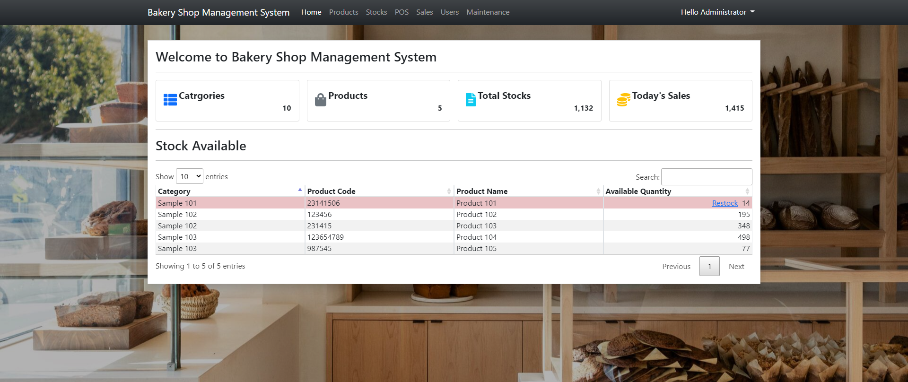](https://www.sourcecodester.com/sites/default/files/images/oretnom23/bsms_home_0.png)
* **Product List**
* [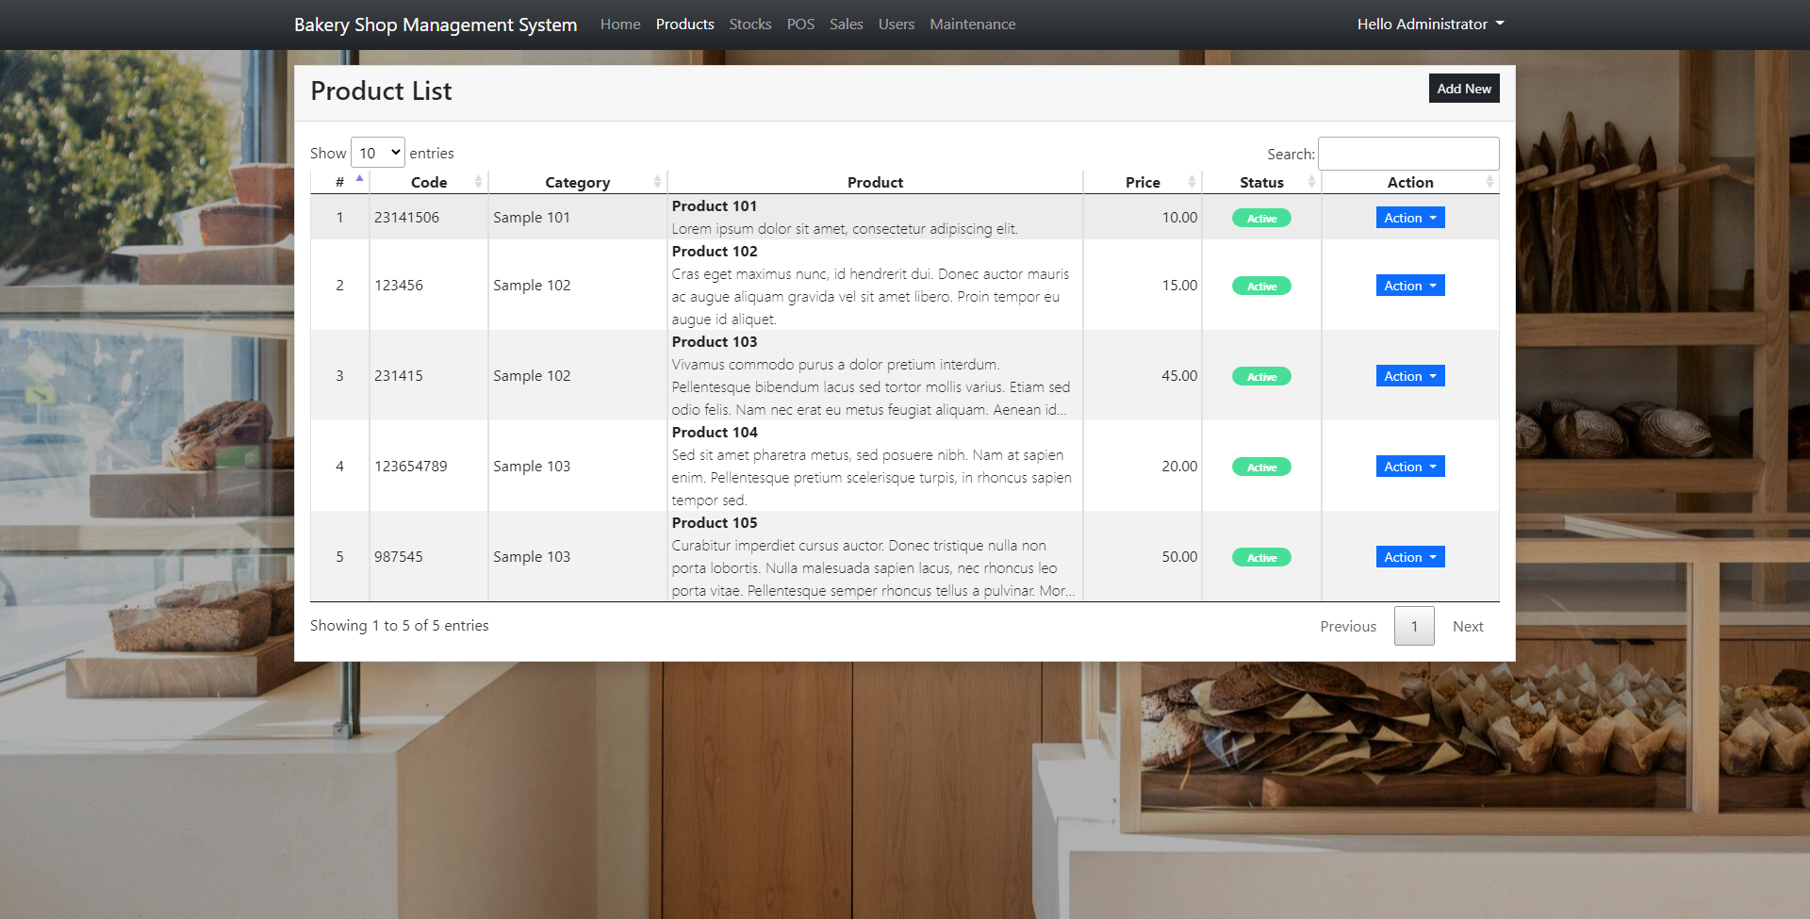](https://www.sourcecodester.com/sites/default/files/images/oretnom23/bsms_product_list.png)
* **POS**
* [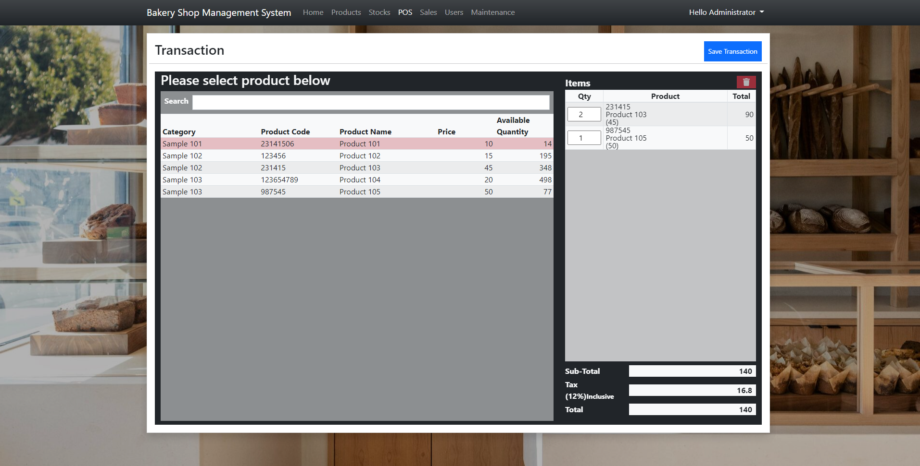](https://www.sourcecodester.com/sites/default/files/images/oretnom23/bsms_pos.png)
* **Receipt**
* [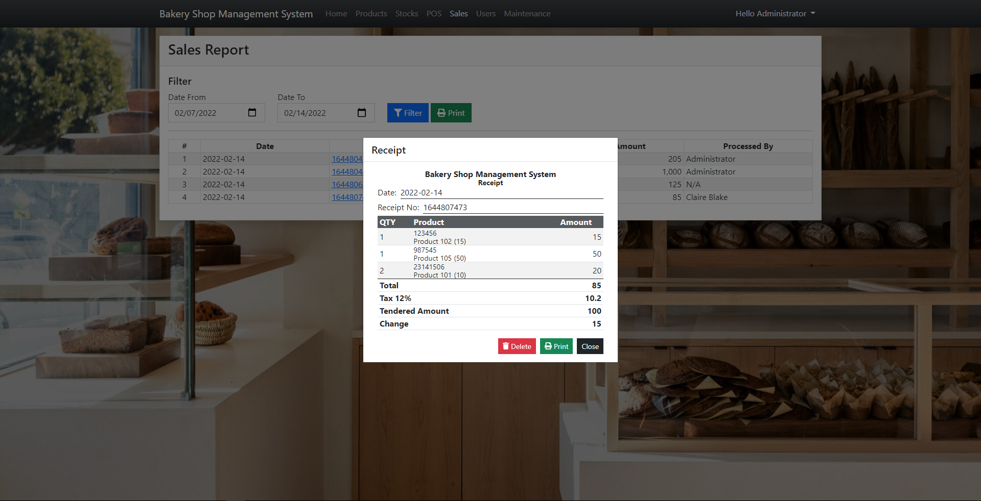](https://www.sourcecodester.com/sites/default/files/images/oretnom23/bsms_receipt.png)
* **Sales Report**
* [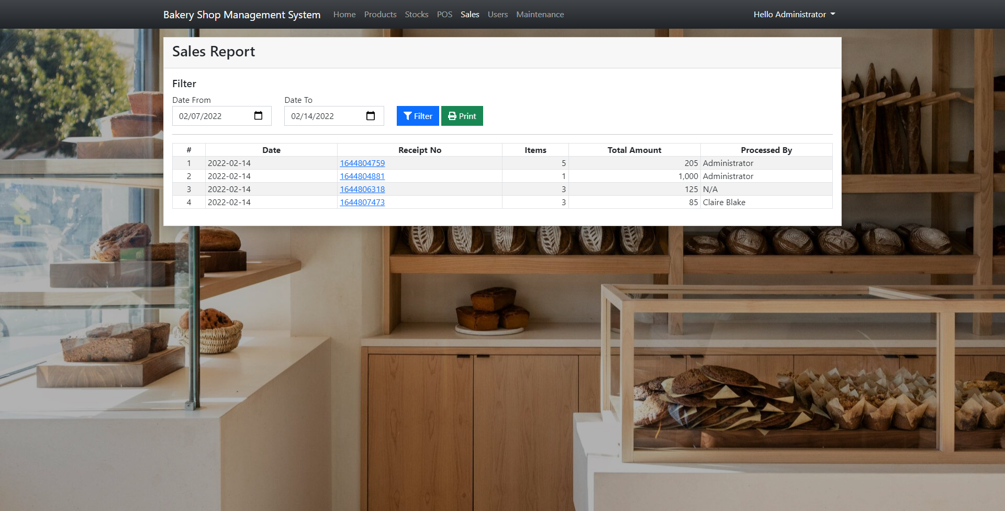](https://www.sourcecodester.com/sites/default/files/images/oretnom23/bsms_sales_report.png)